**Project 1: A Car Game**

**Main Screen (when no profile exists(option 1 is unavailable)):**

**Main Screen (at least 1 profile exists):**

**Profile Selection:**

**Player Profile Options:**

**Car Shop:**

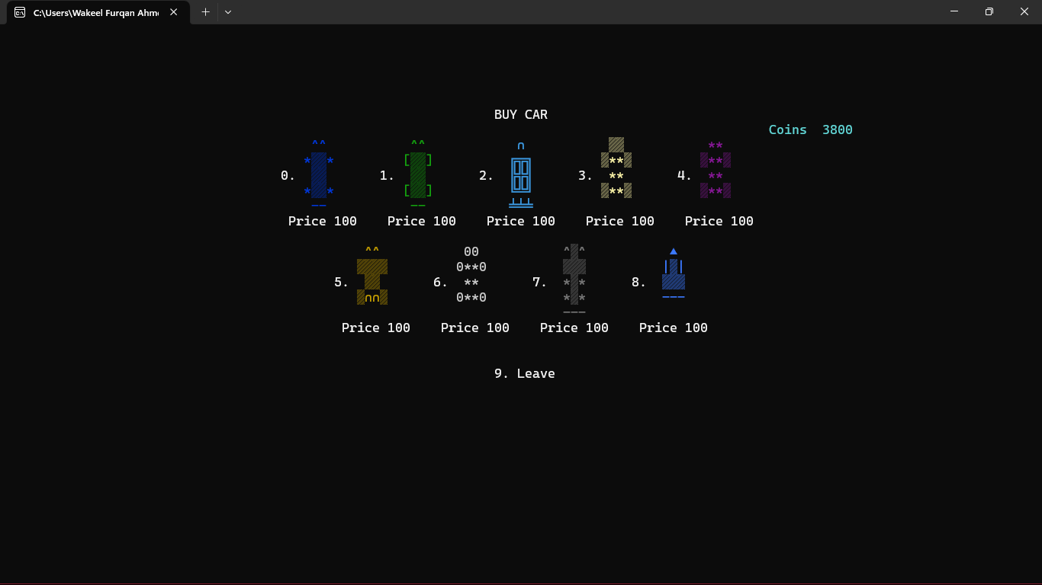

**Game Play Screen:**

**Single Fire (if gun magazine exhausted then gun reloads (unable to fire for few seconds)):**

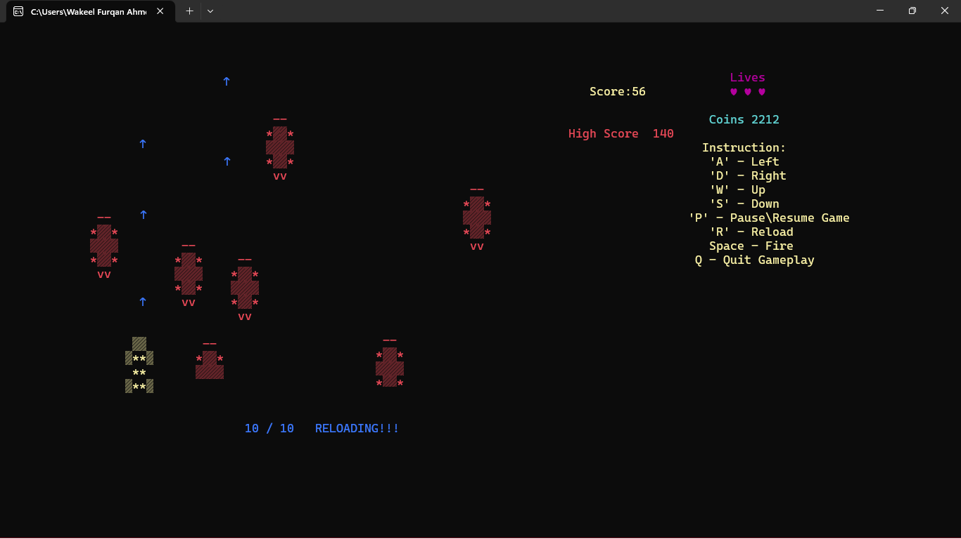

**Game over Screen:**

**Items shop:**

For two videos refer to this link:

<https://photos.app.goo.gl/SEQz8CKsHFcssus89>

In the first video the feature is called **Paint preview**. U simply type the color number(no need to press enter) and the color will be applied on the car on left for preview, when ever u type (20/21) the cancel or apply action is taken.

In the second video, I made text Responsive to the console size, which is not something ready-made(there’s no such feature), it’s my own creation.